**Java Full Stack Development**

**Skilling-4_Part-4**

**ID NO: 190030677 Name: K. Sravani**

**Customer Module:**

**Customerhome.html**

**Checkcustomer Servlet:**

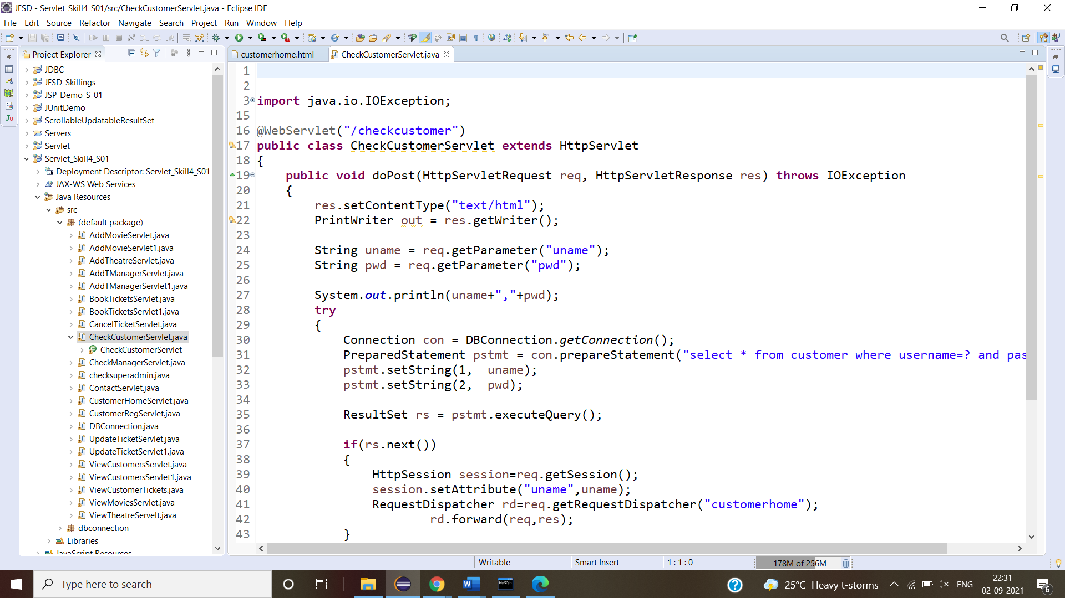

**Viewtheatre Servlet:**

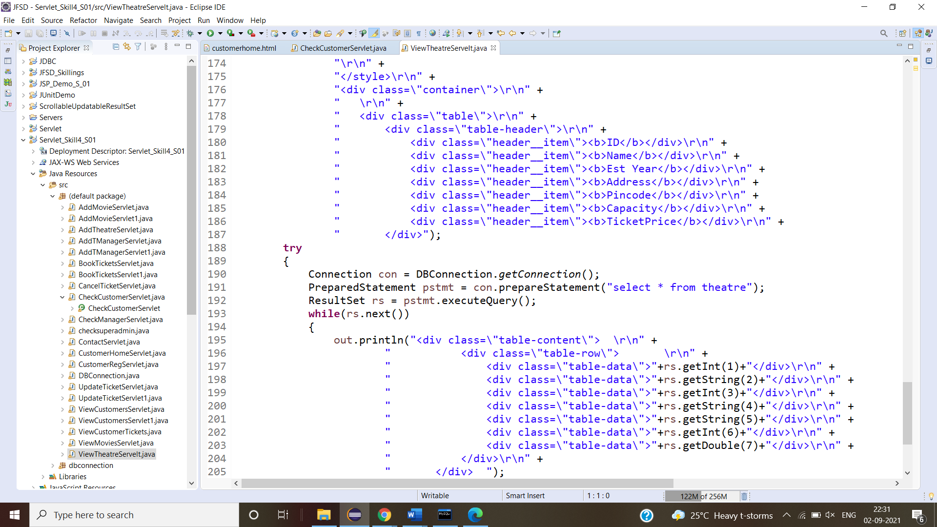

**Viewmovies Servlet:**

**BookTicket Servlet**

**BookTicketServlet1**

**ViewTickets Servlet:**

**Updateticket Servlet:**

**Customer home page:**

**View theatres:**

**View movies:**

**Book Tickets:**

**View Tickets:**

**Cancel ticket:**

**Update Ticket:**

**Data Base data:**

